# Notes

Submit your solutions in the [**SoftUni judge**](https://judge.softuni.bg/Contests/Practice/Index/3124#0) system.

*Notes is an application where we create our own profiles and manage our notes. We can open a details page of each note to see the full content.*

## Skeleton

You are provided with all the **html pages**, all the **images** and the **CSS** for the project.

## Database

You will need **2 models**:

* **Profile**
  + **first_name** - Character field with **max length** of **20 characters**
  + **last_name** - Character field with **max length** of **20 characters**
  + **age** - Integer field
  + **image_url** - URL field
* **Note**
  + **title** - Character field with **max length** of **30 characters**
  + **image_url** - URL field
  + **content** - Text field

## Routes

* <http://localhost:8000/> - home page
* <http://localhost:8000/add> - add note page
* <http://localhost:8000/edit/:id> - edit note page
* <http://localhost:8000/delete/:id> - delete note page
* <http://localhost:8000/details/:id> - note details page
* <http://localhost:8000/profile> - profile page

## Pages

### Home Page – 20p

If there is **no profile** created yet:

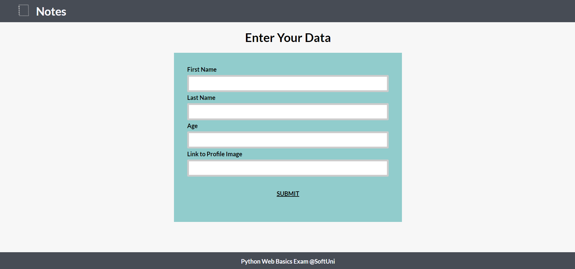

If a profile **has been created** and there are **no notes**:

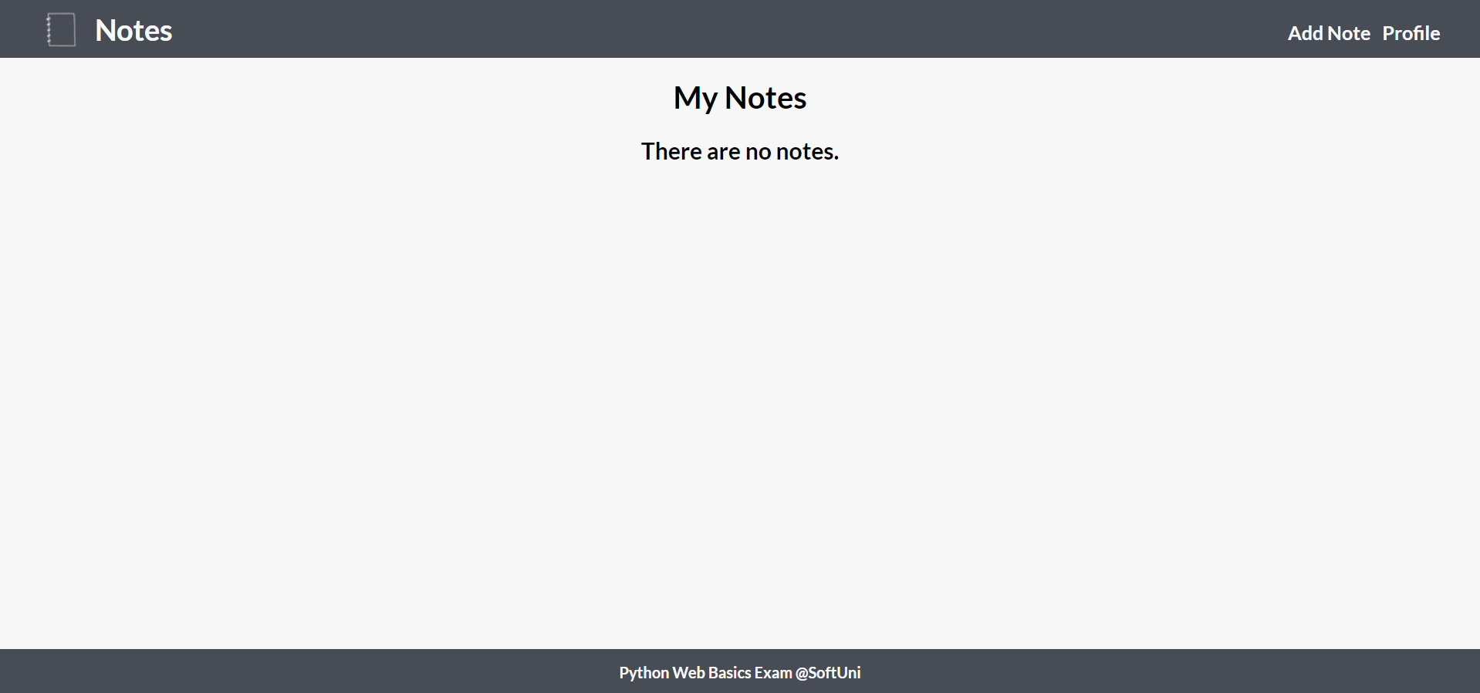

There is a **profile** and **notes**:

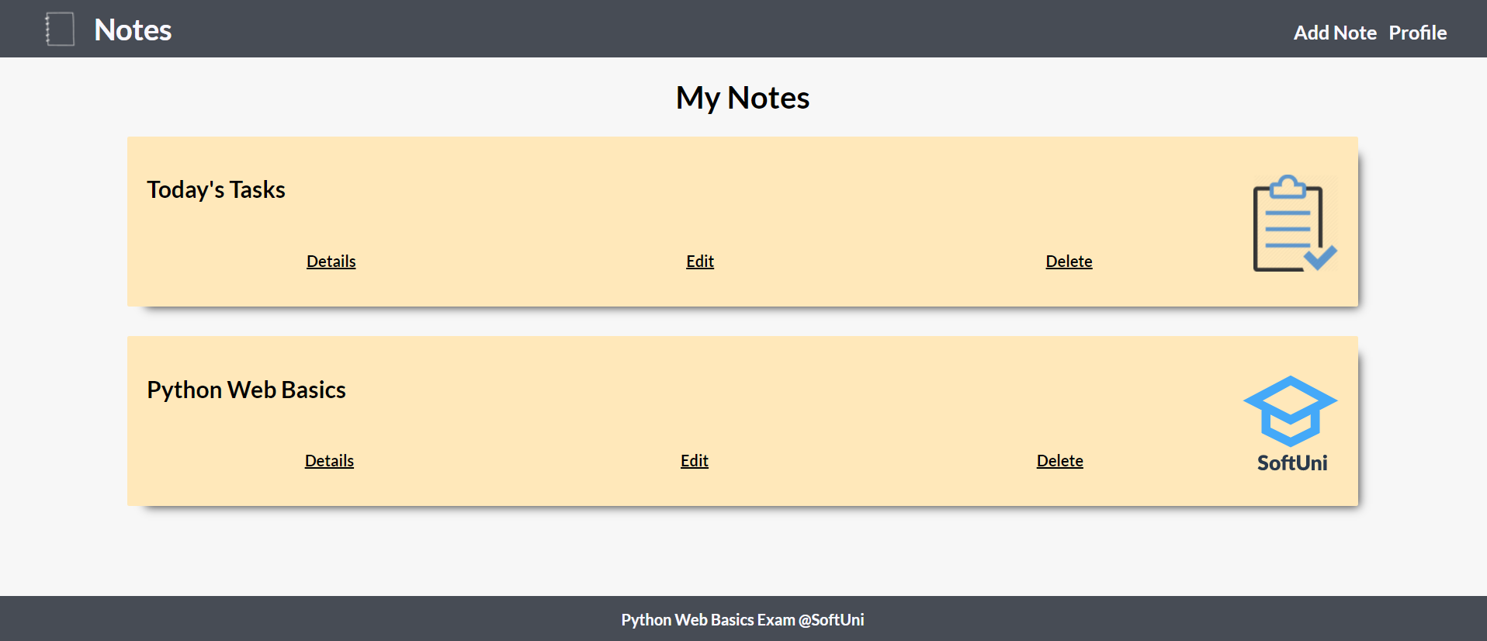

### Add Note Page – 15p

After the button **"Publish"** is clicked, **add** the note and redirect to home:

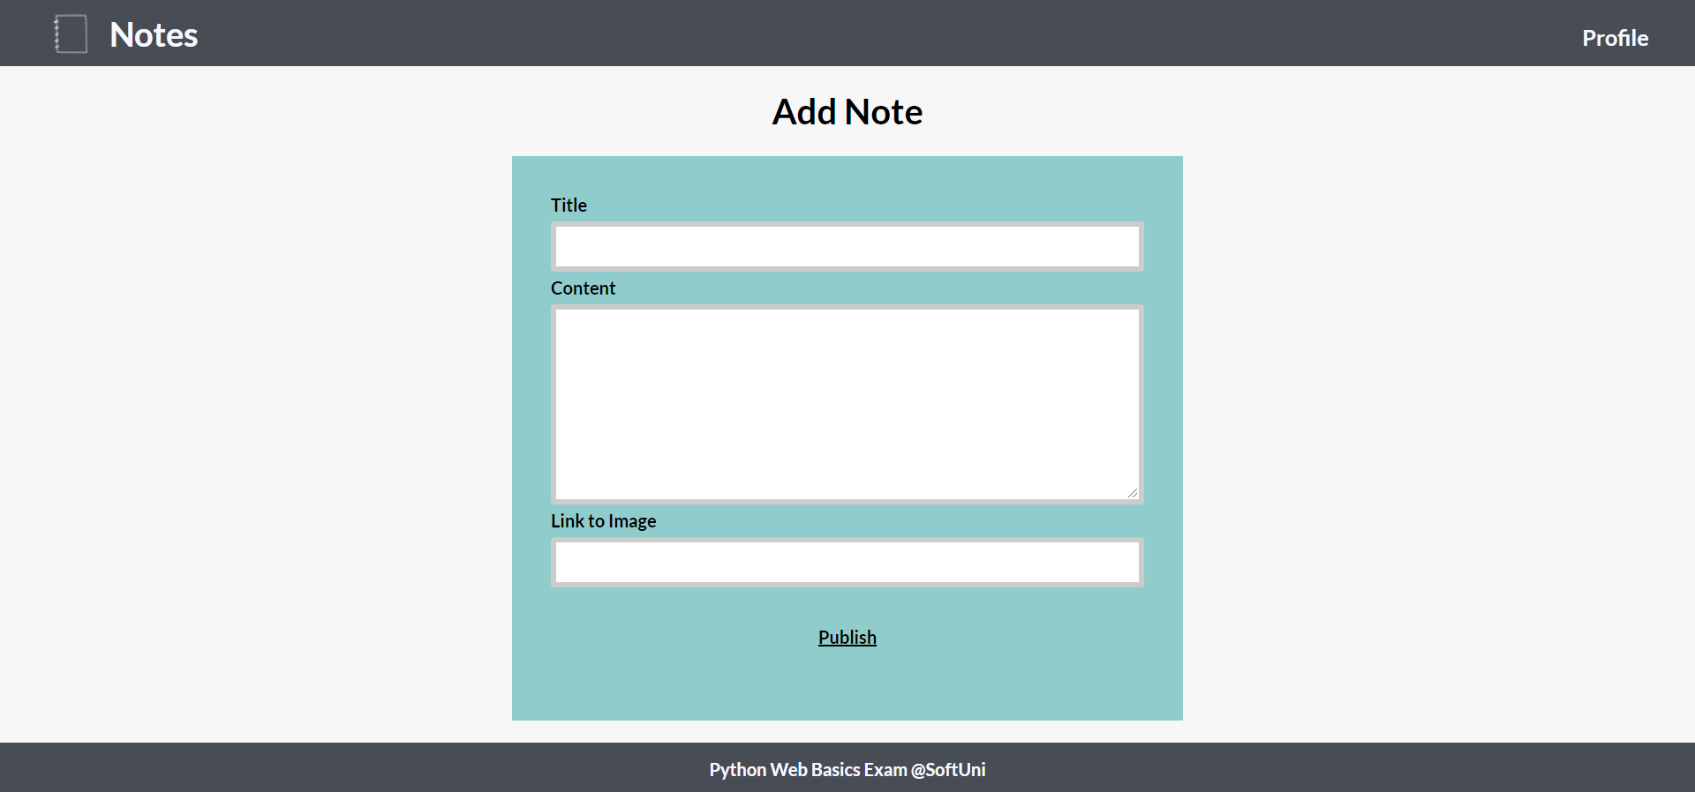

### Edit Note Page – 15p

The form must be **filled** with the **data** of the **note** we want **to edit.** When the button **"Edit"** is clicked, **edit** the note and redirect to home.

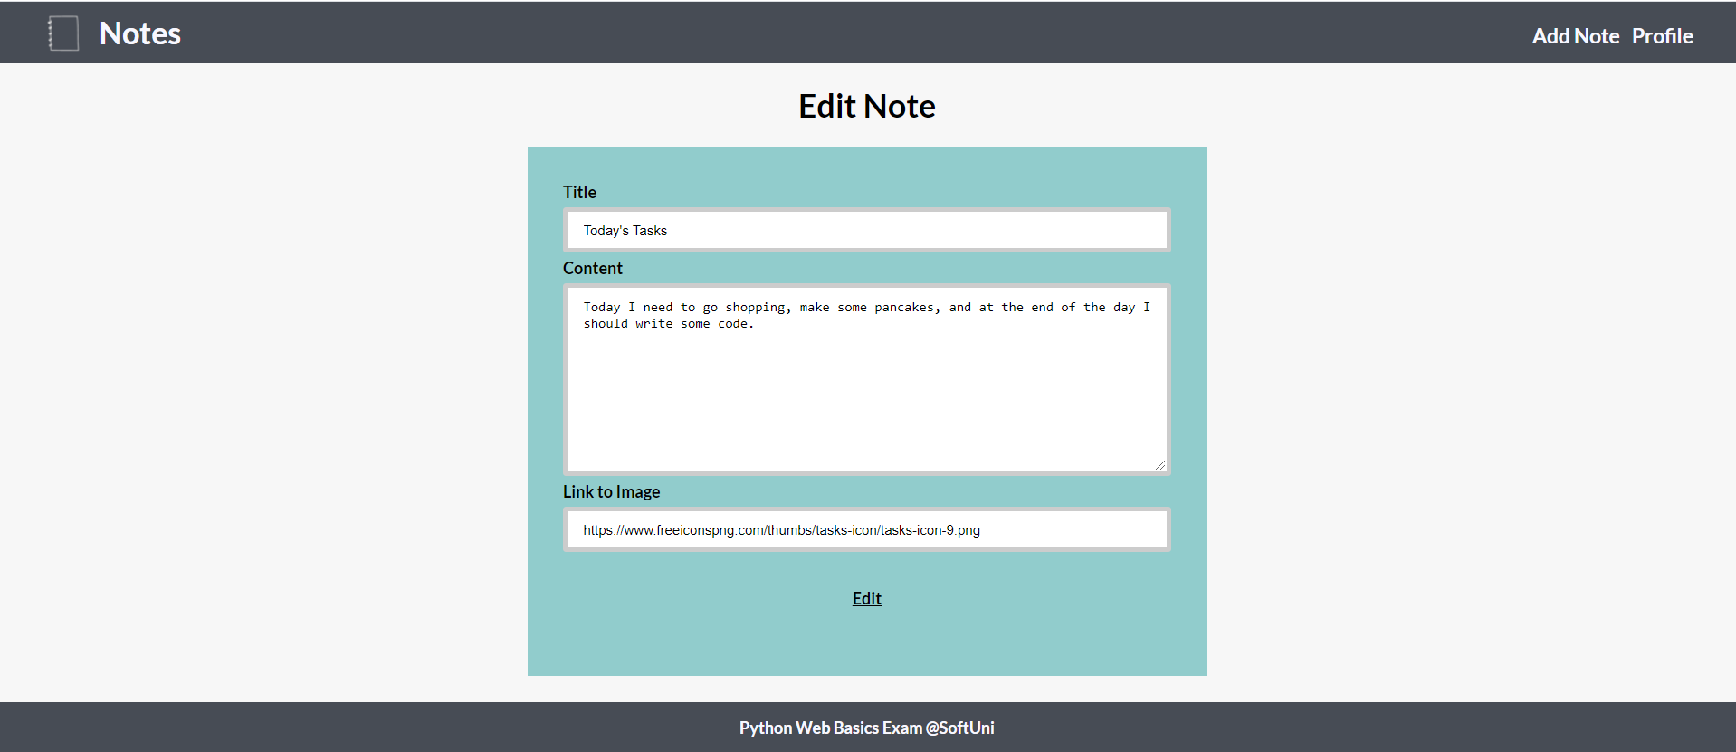

### Delete Note Page – 15p

The form must be **filled** with the **data** of the **note** and the **fields** should be **disabled**. When the button **"Delete"** is clicked, **delete** the note and redirect to home.

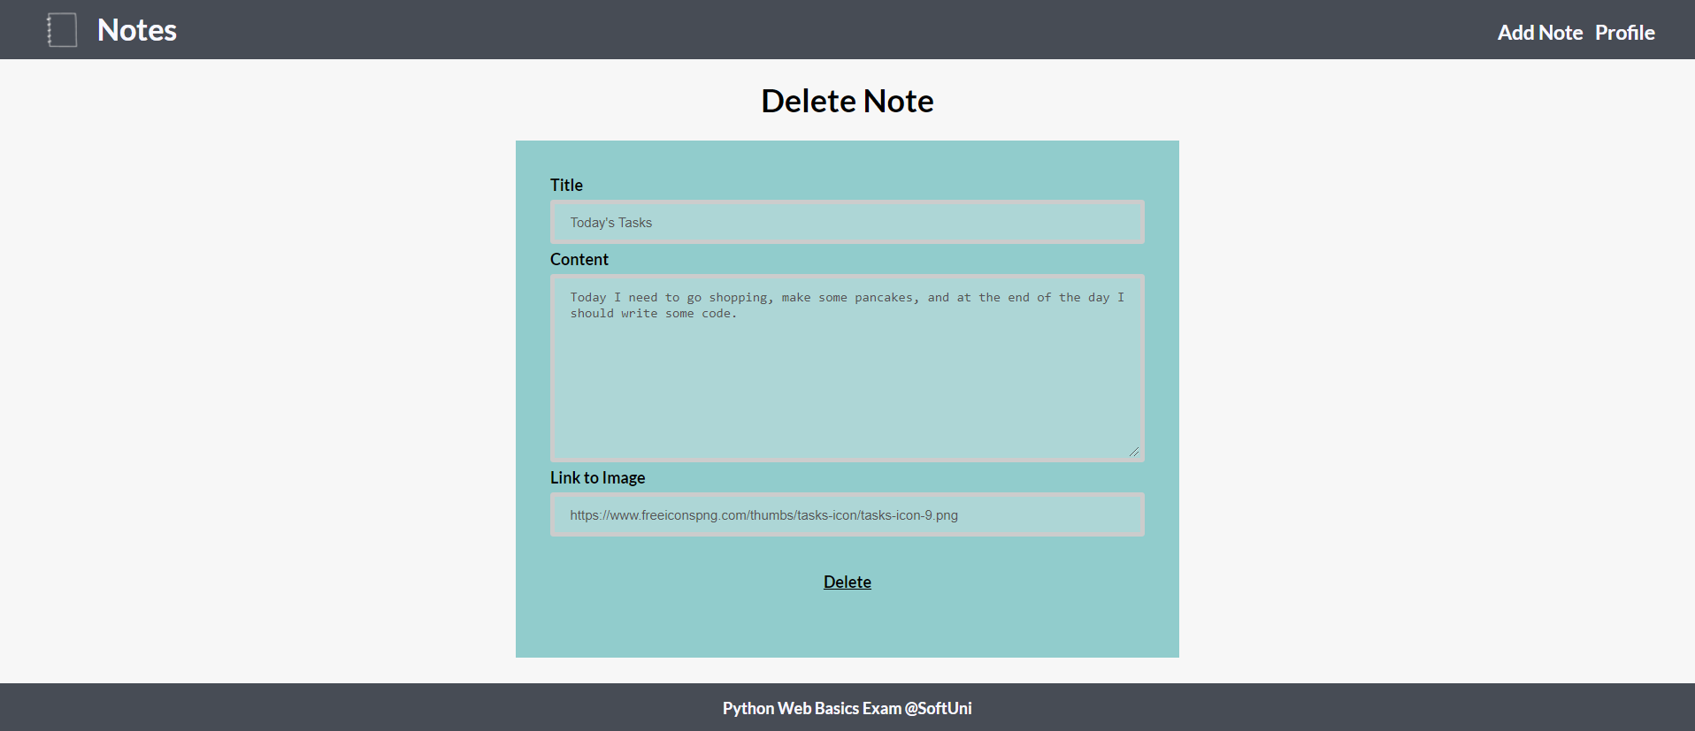

### Note Details Page – 20p

Fill the **needed data**: title, image, and content. Also, the view should have two buttons at the bottom – "Edit" and "Delete".

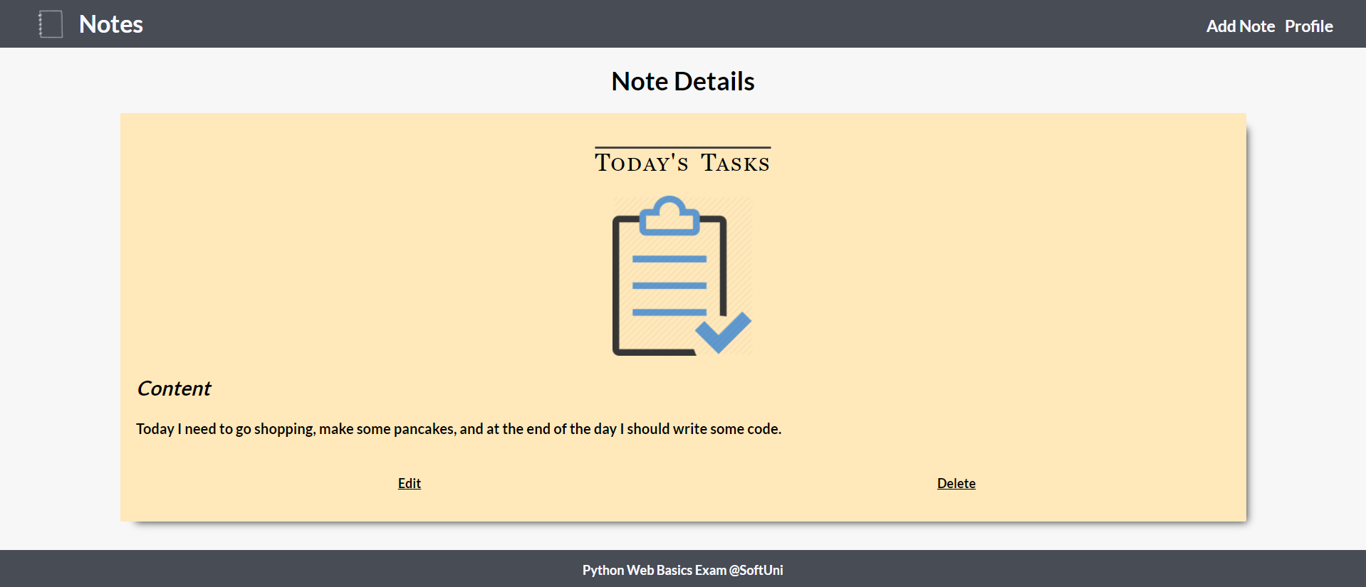

### Profile Page - 15

The **number of notes you have at the current moment** should be displayed on the profile page. When the button **"Delete"** is clicked, **delete** the profile and all notes, then redirect to home page with no profile:

